Gas Engine Test Procedure

SR-30 Gas Turbine Engine System Ground Test Procedure

ARO103L
Introduction to Aerospace Propulsion Laboratory
California State Polytechnic University Pomona, Pomona, CA 91768

Introduction

T
HE Turbine Technologies SR-30 Turbojet engine is a commonly used demonstration tool in the study of engine cycle analysis. This engine, when enclosed in the Turbine Technologies MiniLab™, is instrumented with an array of thermocouples and pressure transducers to allow the operator to monitor the thermodynamic processes taking place within the engine. The SR-30 turbojet engine consists of five main parts: a diffuser, a centrifugal flow compressor, a reverse-flow annular combustor, an axial flow power turbine, and a thrust nozzle (Figure 1.1). The diffuser reduces the velocity of air taken in through the (1) inlet nozzle and carries it to the (2) compressor where the air is then pressurized. The air is then mixed with fuel and ignited in the (3) combustor. As the air expands, it is forced through the (4) turbine, which in turn continues to drive the compressor. The air is then accelerated and released though the exhaust nozzle (5) producing thrust.
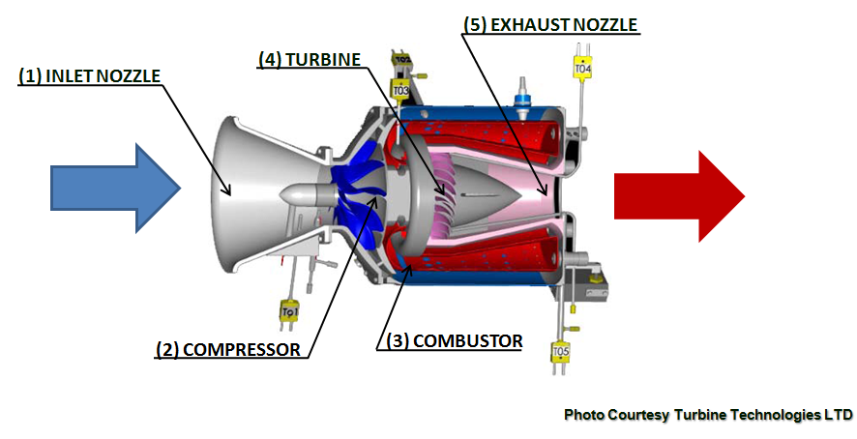

Figure 1.1: SR-30 Gas Turbine Cutaway

The SR-30 jet engine is capable of running a variety of fuels ranging from Kerosene, to Jet-A/A1, to diesel fuel. The performance characteristics for these specific jet fuels can also be compared to determine an optimal fuel to use for SR-30 jet engine testing. The lower specific heating value of Diesel, Biodiesel, and Jet A are 18,486 BTU/lb_{f}, 16,735 BTU/lb_{f}, and 18,610 BTU/lb_{f}, respectively. The density of Diesel, Biodiesel, and Jet A are 7.1 lb_{f}/gal, 7.34 lb_{f}/gal, and 6.76 lb_{f}/gal, respectively. Given these values which fuel would you expect to give the highest performance during which types of flight conditions?

- Turbine Technologies SR-30 Turbojet Engine MiniLab™ & Data Acquisition

The Turbine Technologies MiniLab™ consists of the Turbine Technologies SR-30 turbojet engine, the data acquisition preprocessor, the engine control unit and all operational hardware, and the cabinet within which everything is contained.
The SR-30 turbojet engine is an 11-inch long, 7-inch diameter, cylindrical turbojet engine capable of delivering 40 lbs of thrust at 87,000 rpm. When operating in this condition, the engine has compression and pressure ratios of 3.4 and 30, respectively, and ingests air at a rate approximately 1.1 lbm/s. At maximum thrust, the engine has a thrust-specific fuel consumption of 1.2 hr⁻¹. Mechanically the engine consists of a bell-shaped inlet diffuser, a single-stage centrifugal compressor, a combustor, a single-stage turbine, and a subsonic exhaust nozzle. The engine is instrumented in several locations, described herein, with thermocouples and Serta Systems Model 209 and Model 256 pressure transducers.
Also contained within the MiniLab™ cabinet (Figure 2.1) are the engine control unit (ECU) and all operational hardware necessary for engine operation.

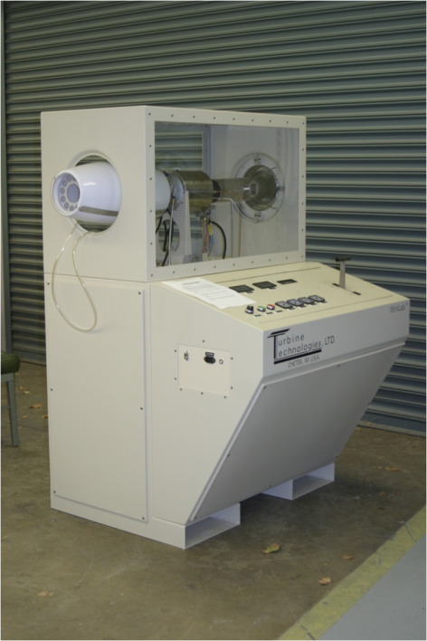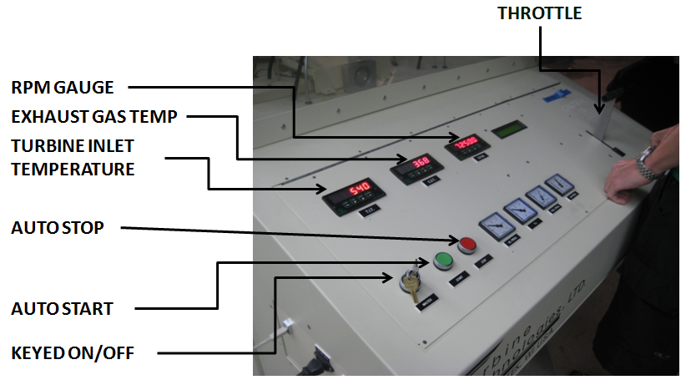

Figure 2.1: Turbojet Engine MiniLab™ Cabinet Figure 2.2: SR-30 Engine Control Unit
with HushKit and Operator’s Station

The ECU is used primarily during engine startup, but also serves as a fail-safe in the case of irregular engine operation. During engine startup, the ECU opens a solenoid connected to a high-pressure air feed. This pressurized air is blown tangentially against the compressor rotor to spin the engine up to approximately 30,000 rpm. When the engine reaches an appropriate speed the ECU turns on the fuel pump and injects fuel into the combustion chamber at approximately 150 psig. When combustion is self-sustaining, the ECU relinquishes command of the engine to the operator and monitors critical engine parameters. In the event of an irregular start, the ECU can abort the start sequence and display the problem on a small LCD screen for the operator to take the appropriate action.
During regular operation, the ECU monitors engine temperature, rpm, and fluid levels to verify that the engine is operating within its operational envelope. In the event that the engine exceeds its operational limits, the ECU initiates an automated shutdown sequence and displays the exceeded parameter for the operator. The operator’s station is positioned in front of one of the viewports and contains the throttle control for the engine and readouts for turbine inlet temperature (TIT), exhaust gas temperature (EGT), engine speed in revolutions-per-minute (RPM), fuel and oil pressure, and feed air pressure (Figure 2.2). Below the enclosure is a compartment that, in addition to the hardware discussed previously, contains a 7-gallon fuel tank and a 3-gallon oil tank. All necessary fuel and oil pumps are contained in this compartment as well. The cabinet is self-contained requiring a 120VAC electrical connection and at least 120 psig air feed in order to function without interruption.
The thermocouple and pressure transducer data are all fed into an IOtech Personal Daq/56 USB Data Acquisition Module (Figure 2.3). This preprocessor compiles the signals from the instrument array into a single USB feed. In addition to the temperature and pressure signals from the engine, the preprocessor collects fuel flow, engine rpm, and direct thrust measurements from their respective instruments (Figure 2.4) within the cabinet and includes it into the output signal. The output signal is formatted to function with IOtech Data Acquisition software installed on an external computer system. The Sensor Parameter Chart (Table 2.1) shows the symbol, function, range, and output values of all sensors.

Instrumentation
Digital: High Speed Data Acquisition System
Data Acquisition Software with Configurable Data Output
Windows® XP Computer for On-Screen Data Display
Single Cable DigiDAQ™ USB to PC Connection
20 Analog IN - 16 Digital IN/OUT - 4 Frequency/Pulse IN
Sensors (Preinstalled and Calibrated)
- Compressor Inlet Temperature and Pressure (T1/P1)
- Compressor Exit Temperature and Pressure (T02/P02)
- Turbine Stage Inlet Temperature and Pressure (T03/P3)
- Turbine Stage Exit Temperature and Pressure (T04/P04)
- Thrust Nozzle Exit Temperature and Pressure (T05/P05)
- Fuel Flow
- Thrust
- Engine Rotational Speed (RPM)
Digital and Analog: As provided on the Operator Control Panel
- Digital Turbine Inlet Temperature (TIT)
- Digital Exhaust Gas Temperature (EGT)
- Digital Engine Rotational Speed (RPM)
- Analog Oil Pressure
- Analog Engine Pressure
- Analog Air Start Pressure

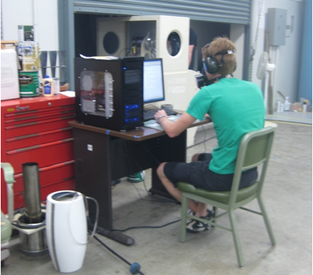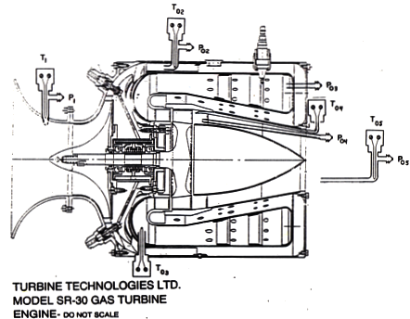

Figure 2.3: IOtech Personal Daq/56 USB Data Figure 2.4: SR-30 Temperature and Pressure Stations
Acquisition Module

Symbol Function Range Output / Sensor
P01 Compressor inlet stagnation pressure (gage pressure) 0-1 psig 0-14.4 mv
P02 Compressor exit stagnation pressure (pitot tube) 0-60 psig 0-60 mv
P03 Combustion chamber static pressure 0-60 psig 0-60 mv
P04 Turbine exit stagnation pressure (pitot tube) 0-5 psig 0-50 mv
P05 Rear cone exit stagnation pressure (pitot tube) 0-5 psig 0-50 mv
RPM revolutions per minute of turbine shaft 0-90,000
FFS Fuel Flow sensor l-150 gph K-type thermocouple
T01 Compressor inlet static temperature Deg. C K-type thermocouple
T02 Compressor stage exit stagnation temperature Deg. C K-type thermocouple
T03 Turbine stage inlet stagnation temperature Deg. C K-type thermocouple
T04 Turbine stage exit stagnation temperature Deg. C K-type thermocouple
T05 Exhaust gas stagnation temperature Deg. C K-type thermocouple
Thrust Pounds Load Cell
TSFC calculated
Specific Impulse calculated
Inlet Nozzle Throat Diameter @ station 1 = 2.78” Exhaust Nozzle Diameter @ station 5 = 2.1875”

Table 2.1 - Sensor Parameters

- Laboratory Experiment Procedure
3.1 Preparation

The class will be divided into teams of 5 to 6 students. Each team will choose a Lead Test Engineer. The Lead Test Engineer will assign the remaining members the following responsibilities:

- Safety Engineer – fire safety, emergency routes, foreign object debris
- DAQ Engineer – sets up and controls data acquisition
- Certification Engineer – logs initial and final engine conditions, documents procedure
- Controls Engineer – operates engine throttle
- Operations Engineer – steps controls engineer through auto-start, operation, and stop sequence

At the designated time, each team will begin the procedure with a brief safety meeting with the Laboratory Technician around the IOtech Personal Daq/56 USB Data Acquisition Module (Figure 2.3). This is also an opportunity for the entire team to become acquainted with the instrumentation of the SR-30 Jet Engine, the sensor measurement interface, and the data acquisition procedure.

3.3 SR-30 MiniLab Normal Operation Procedure (Operations Engineer)

- Engine Set-up Procedure (Team)
  - Position MiniLab™ cabinet in an open, well-ventilated area.
  - Ensure exhaust stream is directed away from any enclosed spaces.
    - Exhaust stream exits to the right, when facing the controls.
  - Connect USB and 120VACcables to the appropriate ports.
  - Connect USB cable to computer.
  - Turn computer on and load pDaq program.
  - Connect shop air hose to receptacle in the back of the cabinet.
  - Verify that air hose is pressurized
    - If pressure gage on control panel does not read any pressure, ensure that the valve to the compressor is open.
    - If valve is open and no pressure is registered on the control panel, consult professor or department technician.

- Pre-Start Procedure (Safety Engineer)
  - Remove all foreign object debris (FOD) from the engine enclosure.
  - Ensure that no FOD can enter the intake during operation.
  - Ensure that all operators and observers are wearing appropriate hearing protection.
  - Locate nearest fire extinguisher and be familiar with its operation.
  - Insert master key and leave in the “OFF” position.
  - Check fluid levels
    - Fuel : At least 3 gallons (half tank)
    - Oil : Level approximately 1-inch below fill spout
  - Ensure air pressure is between 100 and 130 psi
    - If not, followair cleaning procedure. (see Irregular Operation Procedure)
  - Verify that pDaq program is running and armed to collect data.

- Start-up (Controls Engineer)
  - Set master key-switch to “ON”.
  - Check all displays and gages to verify operation.
    - T.I.T. – ON
    - E.G.T. – ON
    - RPM – ON
    - LCD Master Display – ON
    - Oil Pressure – Reads zero
    - P₃ – Reads zero
    - Fuel Pressure – Reads zero
    - Air Pressure – Within acceptable range
  - Set throttle lever to maximum throttle setting.
    - Throttle Position warning will display.
    - If no warning is displayed, consult professor or department technician.
  - Return throttle lever to idle position.
    - LCD display should read “Ready”.
  - Announce intention to start the engine.
  - Countdown to engine start.
  - Push green “START” button.
  - Allow 45 seconds for engine start and warm-up
  - Announce first test RPM (about 52,000 RPM).
  - Throttle until RPM reads approximately 52,000 RPM.
  - DAQ Engineer records the RPM two or three measurements on a pre-prepared data sheet table. The Operations Engineer then signals the Controls Engineer to throttle to the next test RPM and hold while the DAQ Engineer repeats the data recording.
  - The engine will be throttled up in 5 equal increments ( ~ 5000 RPM per increment) up to about 77,000 RPM. The DAQ Engineer will record the data at each increment.
  - After the maximum RPM is attained, the Operations Engineer will inform Controls Engineer to begin the throttle-down sequence. The engine RPM will be decreased in 5 equal increments (~ 5,000 RPM increments) while the DAQ Engineer records the data at each increment until the original RPM is attained.
    - All throttle changes should be smooth and controlled
  - If engine does not start or shuts down mid-start, error message will be displayed on the LCD above the throttle lever.
    - Consult Irregular Operation Procedure.

- Shutdown Procedure
  - Return throttle lever to its idle position.
  - Allow engine 30 seconds at idle to cool down.
  - Push the red “STOP” button.
  - Allow engine sufficient time to come to a complete stop before proceeding with any subsequent operations.

3.4 SR-30 MiniLab Irregular Operation Procedure

- Air Cleaning / Cycling
Performed to cool the engine, blow out pooled fuel, or bleed off air from the compressor.
    - Shutdown the engine if it is not already stopped. (see Normal Operation Procedure, Section 4)
    - Set Master Key-Switch to “ON” position if it is not already there.
    - Set throttle lever to maximum.
      - Throttle Position warning should display
      - If no warning displays on LCD, DO NOT PROCEDE
        - Toggle master key-switch to “OFF” then back “ON”. Begin procedure from step 1.
    - With throttle lever at maximum, push the red “STOP” button. Hold until menu displays on LCD.
    - Push the green “START” button to begin air cycle.
      - Air valve will be opened for 5 seconds during each air cycle.
    - Continue pushing the green “START” button until one of the following are true:
      - T.I.T. reads below 90ºC and the air pressure reads above 100 psi.
      - The air pressure gage reads below 85 psi and begins to climb again.
    - To exit the menu, return throttle lever to idle position.
    - Let engine come to a complete stop. Proceed with normal operation.

The following warnings will be displayed on the LCD above the throttle lever in the event of an automated engine shutdown. A description of each event and appropriate action to be taken are listed below:
- Over Temp.
Engine temperature has exceeded normal operating levels.
    - Allow engine sufficient time to come to a complete stop.
    - Perform air cleanings (see Air Cleaning / Cycling).
- Over Speed
Engine has exceeded safe RPM levels.
    - Allow engine sufficient time to come to a complete stop.
    - Restart following Normal Operation Procedures
    - Maintain throttle settings below 85,000 RPM
- Hot Start
Insufficient airflow or excessive fuel has caused the engine to overheat on startup. In some cases, this can cause irreparable damage to the engine. Exercise extreme care in restarting the engine following this procedure.
    - Allow engine sufficient time to come to a complete stop.
    - Verify that the engine is not on fire.
      - If engine is on fire, put it out and alert professor or department technician.
    - Verify sufficient air pressure.
    - Perform air cleaning(s) (see Air Cleaning / Cycling).
      - Fuel may leak from engine vent holes.
    - Restart the engine following Normal Operation Procedure.
    - Repeat occurrences of this problem are indicative of a fatal flaw within the engine. Consult department technician.
- Hung Start / False Start
Engine is unable to achieve idle RPM during startup.
    - Allow engine sufficient time to come to a complete stop
    - Perform several air cleanings.
    - Restart following Normal Operation Procedure.
    - If problem persists, consult professor or department technician.
- Oil Level
Oil level is below manufacturer recommended level.
    - Consult professor or department technician.
    - After oil has been added to engine reservoir, restart following Normal Operation Procedure.
- Fuel Level
Fuel level is below manufacturer recommended level.
    - Consult professor or department technician.
    - After fuel is added, restart following Normal Operation Procedure.

3.5 Test Procedure: Data Collection Procedure (DAQ Engineer)

This section describes how to auto-record all of the engine instrumentation data during the runs (scheduled in Section 3.6). However this data is for back-up purposes only. You will use the manually recorded data described in Section 3.6 for the data plots and discussion for Section 5.0.

- Make sure the computer is on and connected to the jet engine via USB cable
- Open pDaqView by clicking on the desktop shortcut
- Open the Configuration File folder and load the “Factory Config.CFG” file
- When prompted to save the configuration select “No”
- Open the “Configure Data Destination” window
- Choose a save destination
- Enter a file name
- Click on “Conversion Formats” and verify that “ASCII Text” is selected
- Open the “Configure Acquisition” window
- Trigger Tab: for Source, select “Manual”
- Post-Trigger Tab: for Stop On, select “Manual”
- Arm Trigger for Disk Recording
- Click to start data collection when ready
- Click to stop data collection when finished

3.6 Test Procedure: Engine Run Schedule and Manual Data Recording for Data Plots for Section 5.0

The team will seat them selves around the table that holds the data computer display screen each with their data sheet table. After the engine is started by the lab technician, the team leader will assume control of the throttle to control the RPM. The leader will call out the first RPM (about 44,600 RPM). The team then records the RPM and their two or three measurements on their pre-prepared data sheet table. The team leader then increases the RPM to the next test RPM and holds for about 5 to 10 seconds while the team repeats the data recording. The RPM will be successively increased in 5 equal increments ( ~ 5000 RPM per increment) up to about 80,000 RPM, while the team records the data at each increment. After the maximum RPM is attained, the leader then reduces the RPM in 5 equal increments (~ 5,000 RPM increments), while the team records the data at each increment until the original RPM is attained. Then the team turns control of the engine back to the technician.
You will record the manually recorded data on a template given on the website. The manually recorded data will be used for the data plots and interpretation as discussed in Section 5.0. the computer recorded data is for back-up and checking the accuracy of the manually recorded data only.

