**California State Polytechnic University, Pomona**

**Aerospace Engineering Department**

**ARO 309 – Astronautics and Spacecraft Design**

Homework – 04

Due Monday 2/10

1. **[2 points]** Problem 4.1 Part b (Curtis: Section 4.3)

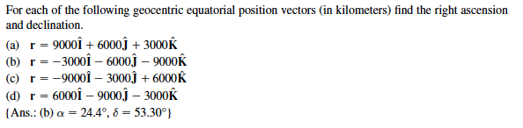





1. **[10 points]** Problem 4.4 (Curtis: Section 4.4)

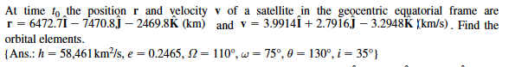

[Note: these are not the classical orbital elements they are looking for, so find h instead of a]

1. **[20 points]** Assuming your spacecraft is in orbit around the Earth and has the following orbital elements at time t0:

 

* 1. Calculate the geocentric equatorial position and velocity at time t0 for the above orbital elements above.
  2. The orbit advances 1 minute (so delta-t = 60 sec). Compute the mean motion, the Mean anomaly, the Eccentric anomaly, and the true anomaly after the detla-t (so after 60 seconds).
  3. Calculate the position and velocity after the 60 seconds in the perifocal coordinates.
  4. Compute the new assuming the affect of J2. So  and .
  5. Now compute the transformation matrix to transfer from the perifocal coordinate system to the geocentric equatorial frame with the updated  from above.
  6. What is the new position and velocity vector after the 60 seconds?
  7. What is the new set of orbital elements after the 60 seconds?